**US POLICE SHOOTINGS REPORT**

by

Abigail Larkai

Afia Asamoah-Frimpong

Adjei Daniel Asenso

Margolda Bosu

Orthancia Bajola

**INTRODUCTION**

In recent years, the United States has witnessed a rise in cases of police killings of civilians, particularly among people of colour. These cases have sparked a national conversation about the role of race in law enforcement and the criminal justice system. The current socio-political circumstances in the United States (US), constituted by the increasing visibility of police shootings of Black people and other racial minorities, present a compelling moment for analysing how news media report about law enforcement, culpability, and racism (Shrikant & Sambaraju, 2021).

The purpose of this analysis is to delve deeper into this issue, and shed light on the story of racism in America. It is hypothesized that racial minorities are disproportionately affected by police shootings compared to the overall population. This dataset contains important information about the victims of police killings, consisting of their name, age, gender, and race, as well as the circumstances surrounding the shooting/killing. These circumstances include date of event, where it happened, how they were shot, if they attacked, whether they were holding weapons, if they showed signs of any mental illness, if the policeman wearing a camera and recorded the incident, and whether the suspect attempted to flee or not and the mode of escape. Apart from that, a category column holds type of weapon used by the suspect.

We evaluated race-specific odds and probabilities whether victims of police killings exhibited mental illness, were armed with a weapon, or attempted to flee the scene at the time of their killing. Analysis was made to further clarify the victim's age, gender, date of killing, and geographical clustering. By examining this data, we hope to gain valuable insights into this complex and pressing issue.

**METHODOLOGY**

The analysis of the US police killings dataset was conducted using Power BI and Power Query as the primary tool to derive insights related to race and incident patterns. The dataset was presented as a CSV file. Power BI offers powerful data visualization and modeling capabilities, making it ideal for this analysis.

The first step involved importing the dataset into Power BI. After loading the data, an initial data cleaning process was conducted to ensure data accuracy. This included checking for missing or incorrect values, verifying data types, and addressing any inconsistencies. Key columns such as race, gender, location, weapon type, and mental health status were reviewed and normalized to ensure they could be properly analyzed.

Next, relationships between different elements of the data were established to create a model for the data. The “Star schema” was used for our data modeling. For example, race and gender were linked to the outcomes of incidents.

Power BI's visualization tools were used to transform the raw data into meaningful insights:

Demographic Analysis: Bar charts and pie charts were created to visually represent the distribution of threat level, signs of mental illness and arms category used in the total number of occurrences. This allowed for quick identification of the state of mind and the arms disproportionalities used in the incident.

Weapon and Incident Analysis: Stacked bar charts were used to show the various types of threat levels and the type of flee observed by suspects and how these vary by race.

Time Series Trends: An area chart was created to observe trends over time, particularly during politically significant periods. This chart was created to visually represent the distribution of victims by race, date it happened and the total number of occurrences. This helped to highlight trends over time based on race.

Police Response Evaluation: A detailed analysis of police behavior was conducted using visuals that showed body camera usage across incidents. Further, the analysis explored the role of racial disparities in police response, particularly in cases where suspects were fleeing or attacking.

Interactivity and Filters: Power BI’s interactive filters and slicers were utilized throughout the report. Users can filter the data by race, gender, region, and time period to drill down into specific subsets of data. This interactivity allows for a deeper understanding of how different factors, such as race and mental illness, intersect with the nature of police responses.

Insights Generation: The final step involved interpreting the visuals and generating insights. The focus was on identifying patterns of racial disparities, particularly with respect to police response, body camera usage, and suspect behavior. Through Power BI’s dynamic visuals and data manipulation features, a clearer visual was used, allowing for in-depth exploration of the underlying factors contributing to racial disparities in police killings in the US.

**RESULTS AND DISCUSSION**

The records accounted for a total number of 4895 occurrences of shooting incidents in the US by the Police Service of the United States in 2287 Cities and 51 States. To solve the arising issues on Racism and the US Police, this data provided ample information to help unravel the mysteries. The data only recorded the deaths which helped eliminate redundancies in the sense that the Police was being accused of Racism based on the death count and not those who were arrested.

We realized from the dataset that the male gender was most culpable to be gunned down or shot and tasered, accounting for 95.46% of the entire records provided. This explains the fact that males are more aggressive and non-submissive as compared to female culprits.

From the data, the race with most culprits were the whites, followed by the blacks and then the Hispanics. Most of the races were aggressive and attacked with various weapons (mostly with guns) and only few showed signs of mental illness. For that matter, we cannot blame the aggression on mental illness.

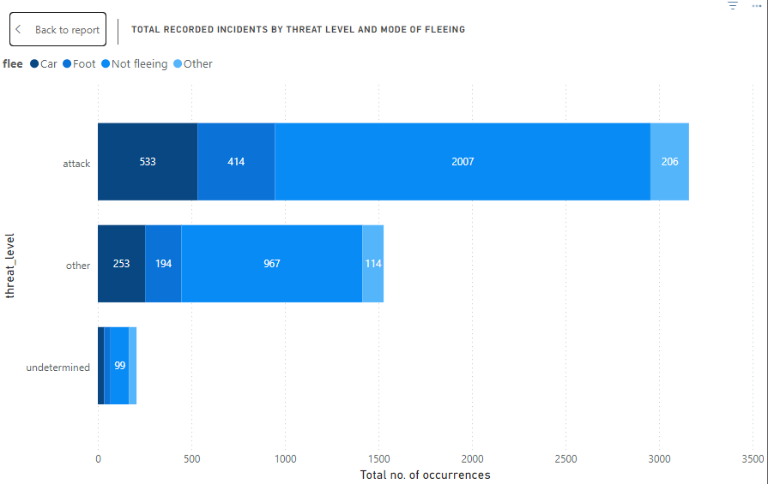

Chart 1

Chart 1 studies the threat level by the Total number of occurrences. We realized that most of the culprits attacked the Police which warranted the Polices’ action(s). From the Legend, the mode of fleeing was plotted, showing that most of the culprits were still in the act of aggression when the Police meted out punishments to neutralize them. We can therefore agree that most of the culprits were aggressive and not submissive which caused the Police to react and not because of bias or Racism.

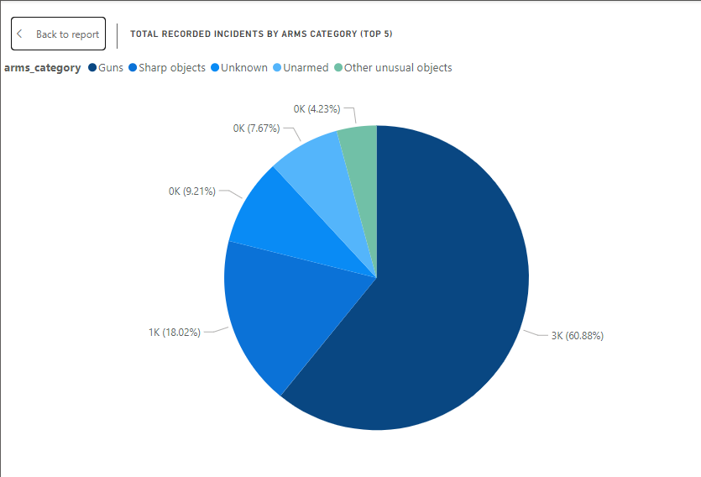

Chart 2

The pie chart depicts the arms category that was prevalently possessed by the culprits. This chart alone explains the fact that all the culprits were the aggressors because it is not normal to be carrying weapons around without being audited by the Police. Apart from the 7.67% of culprits that were unarmed, the rest were armed with various weapons with guns being the dominant weapon, amongst others such as sharp objects (machetes, etc.), unknown arms and other unusual objects (in that order).

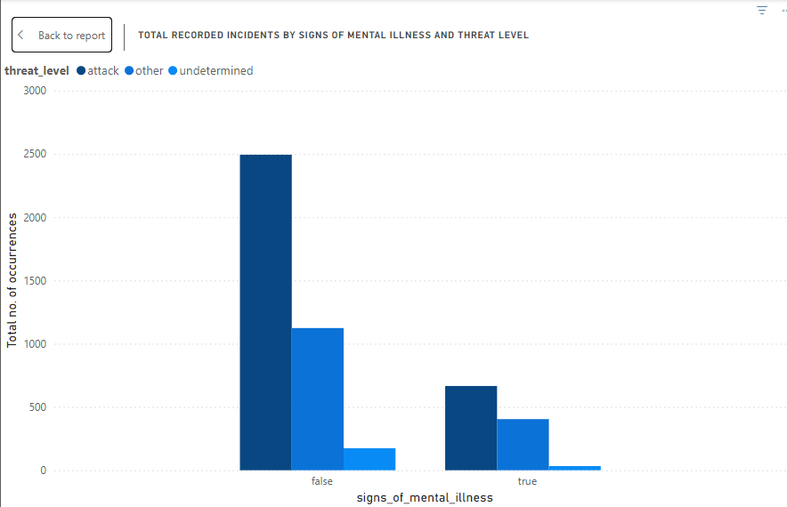

Chart 3

This chart shows the number of occurrences that happened as a result of mental illness or not, along with their various threat levels. We realized that most of the cases were not as a result of mental illness. Despite the fact that a considerable number of culprits showed signs of mental illness, the larger number suggested that mental illness could not be blamed for the aggression. Other causes like substance influence should be considered.

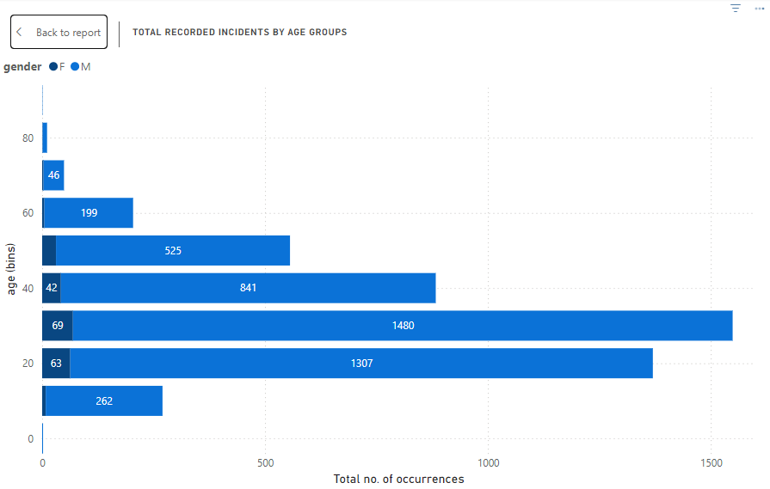

Chart 4

Chart 4 describes the ages of culprits by the total number of occurrences. The chart revealed that most of the culprits were in the youth bracket. The youth are energetic and exposed to aggression and un-submissiveness.

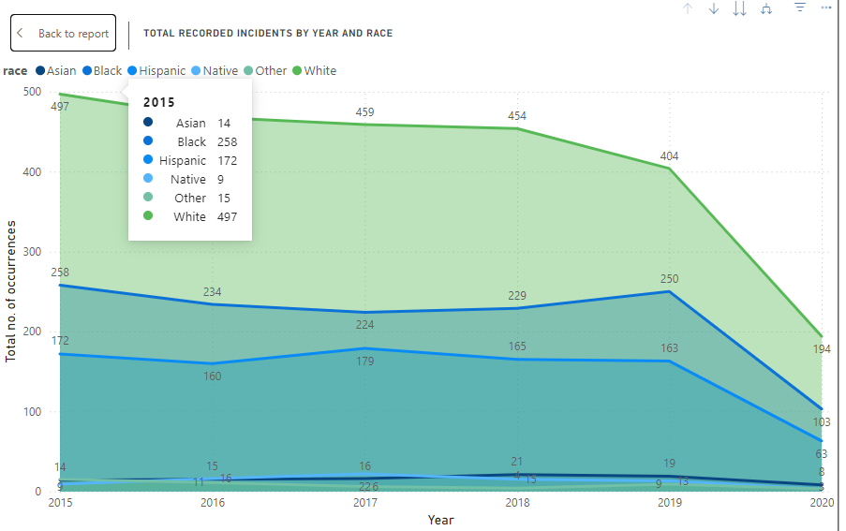

Chart 5

The Area chart evaluated the total number of occurrences of each race by the years (2015-2020). In 2015 the races recorded a significantly high number of suspects as compared to the later years. By 2020, there was a significant decrease in deaths which could be as a result of the police taking cautious measures to reduce the mortality rates. We realized that over the years, the whites were the most on the victim list, followed by the blacks and then the Hispanics. This suggests that the Police killings cannot be as a result of Racism since they make up the racial majority in the country. The Whites’ death count was significantly higher than that of the Blacks who were followed closely by the Hispanics.

From the above analysis we can infer that Whites are most likely to exhibit aggression towards the Police as compared to the other racial minorities, leaving the Police with no choice than to defend themselves.

**SUMMARY OF KEY INSIGHTS**

* The most aggressive race are the Whites.
* Most Police-suspect incidents are not accountable to mental illness.
* A greater part of the occurrences was as a result of the Police reacting to the culprits and not just random attacks by the Police.
* Majority of the suspects carried guns.
* The male gender was more culpable than females.
* The youthful age groups (20 to 40 years) were more dominant than the other age groups.

**CONCLUSION**

From this dataset, we can conclude that the issue of police shootings in the U.S. may not be as directly linked to racism as often suggested. The data shows that, over time, police killings have decreased for all racial groups as at 2020. However, it’s crucial for police forces to ensure that body cameras are consistently used during their operations in order to avoid bias and the absence of evidence.

**REFERENCE**

Shrikant, N., & Sambaraju, R. (2021). ‘A police officer shot a Black man’: Racial categorization, racism, and mundane culpability in news reports of police shootings of black people in the United States of America. *British Journal of Social Psychology*. https://doi.org/10.1111/bjso.12490